Install Virtual box/VMware Workstation with different flavors of Linux or windows OS on top of your present windows environment.

Procedure:

Step1: Goto VMware Workstation to download virtual box in an Operating System.

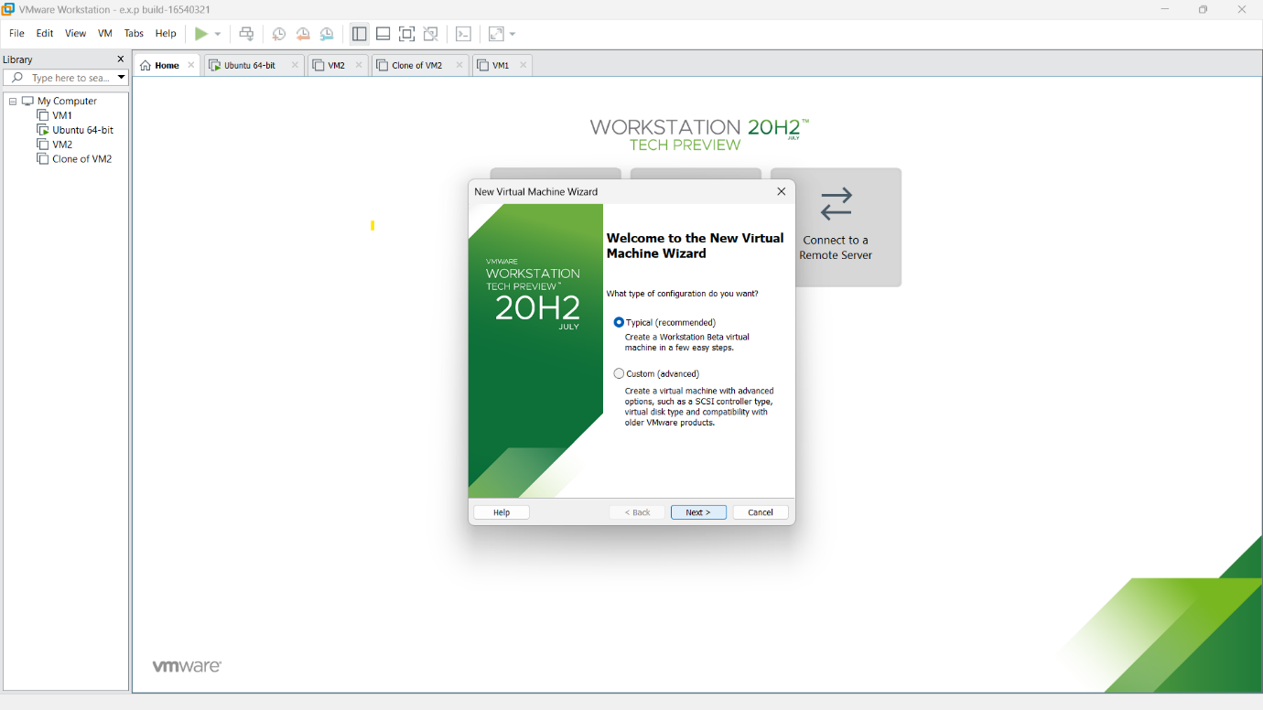

Step2: Processing all the steps from the starting of Virtual machine opening.

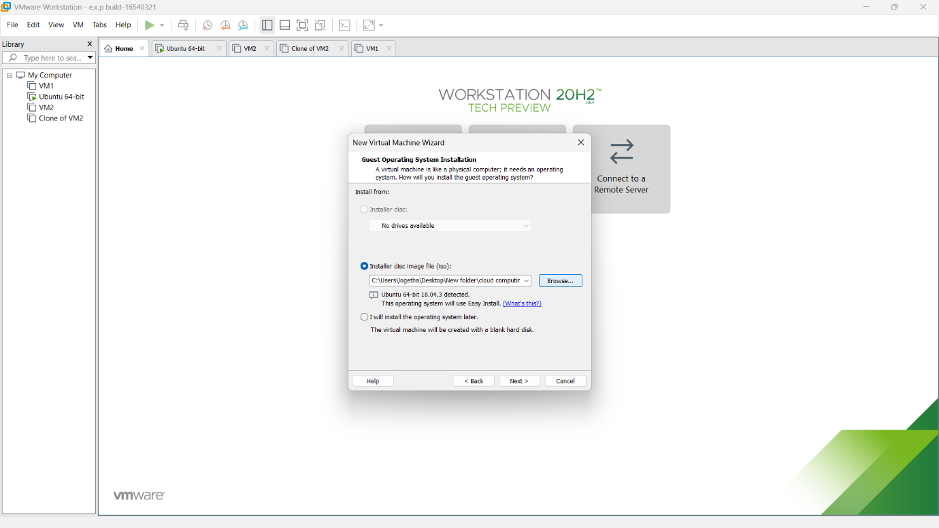

**Step3:** Then provide an appropriate name and password for the os which is going to be installed.

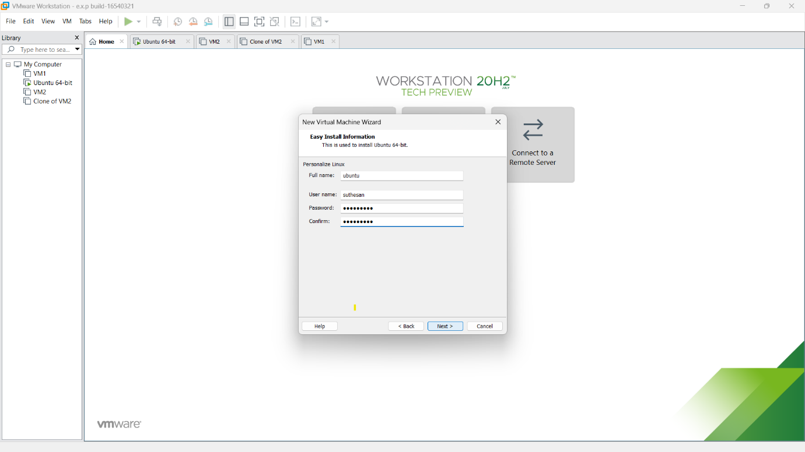

Step4: Then provide the name for our application and browse the location in which needs to be saved.

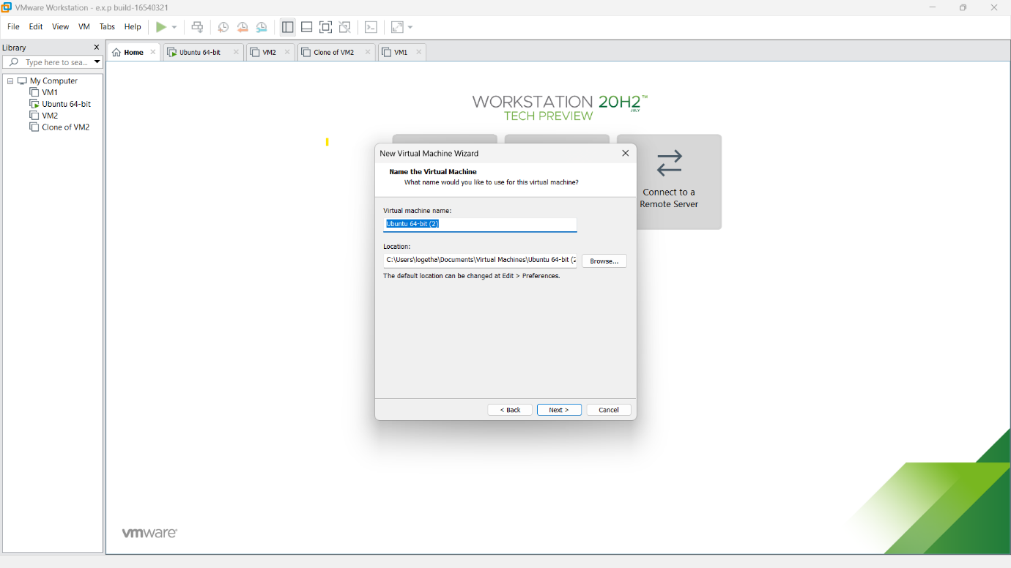

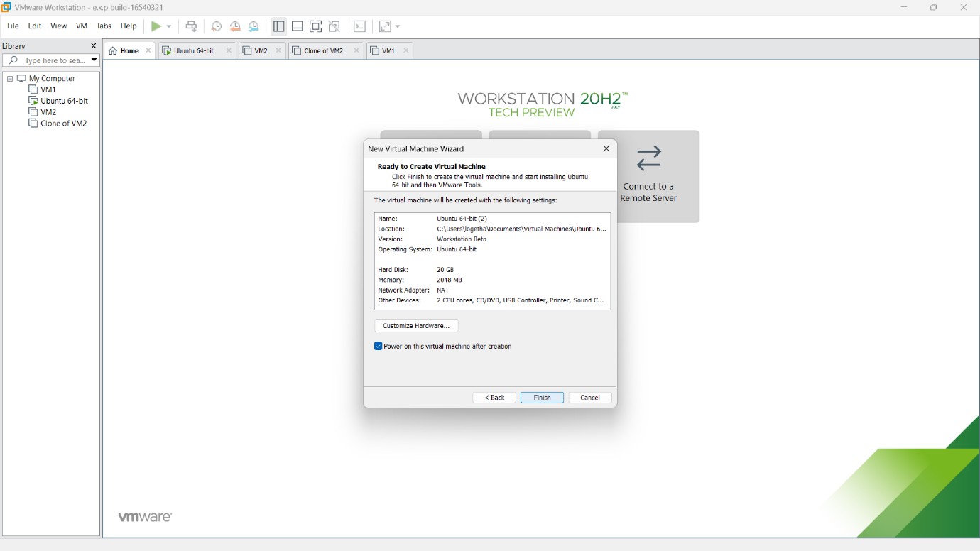

Step5: The Installation process will be started.

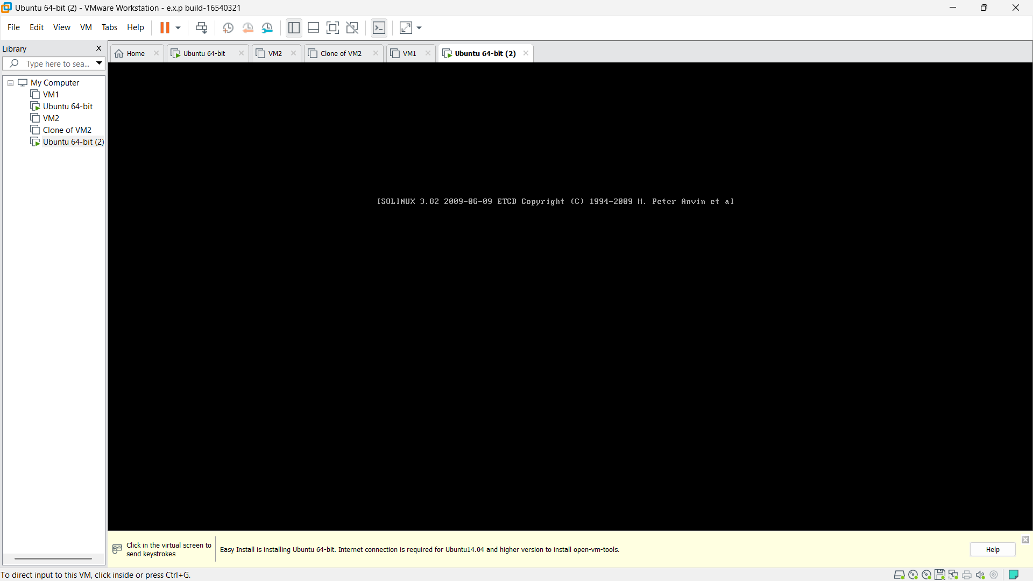

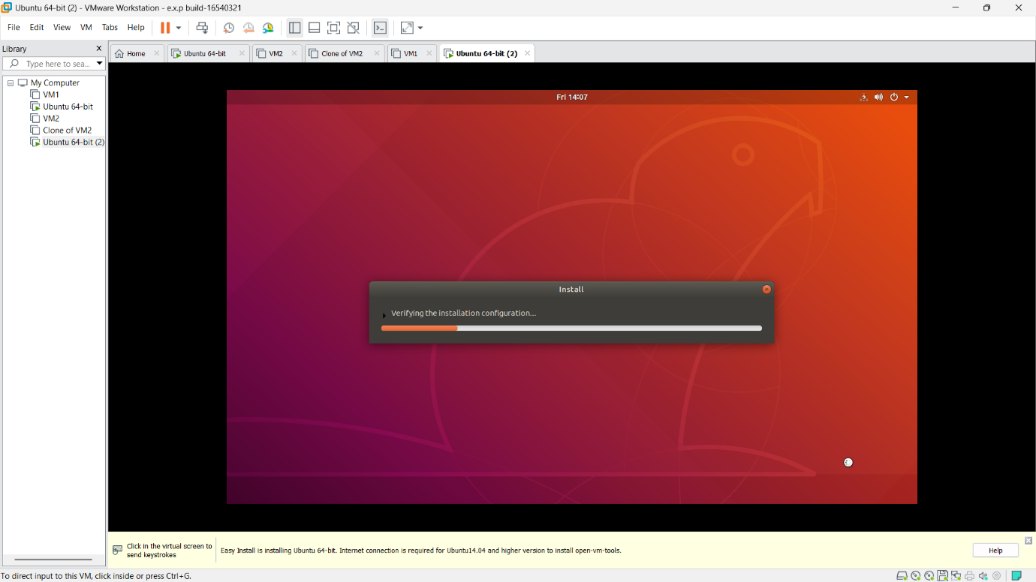

Step6: After completion of installation enter the needed credentials to login the Ubuntu software.

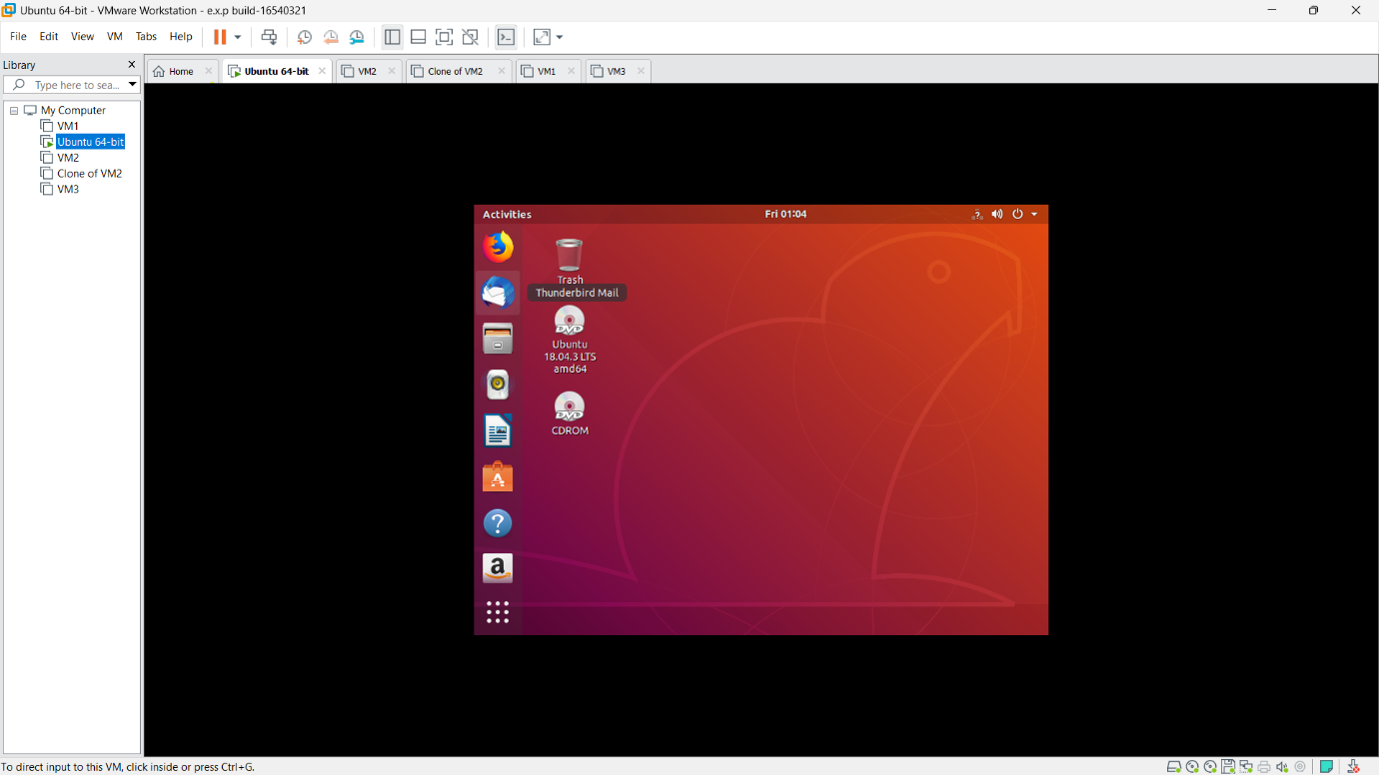

Step7: GotO Chrome in the and download the virtual box.

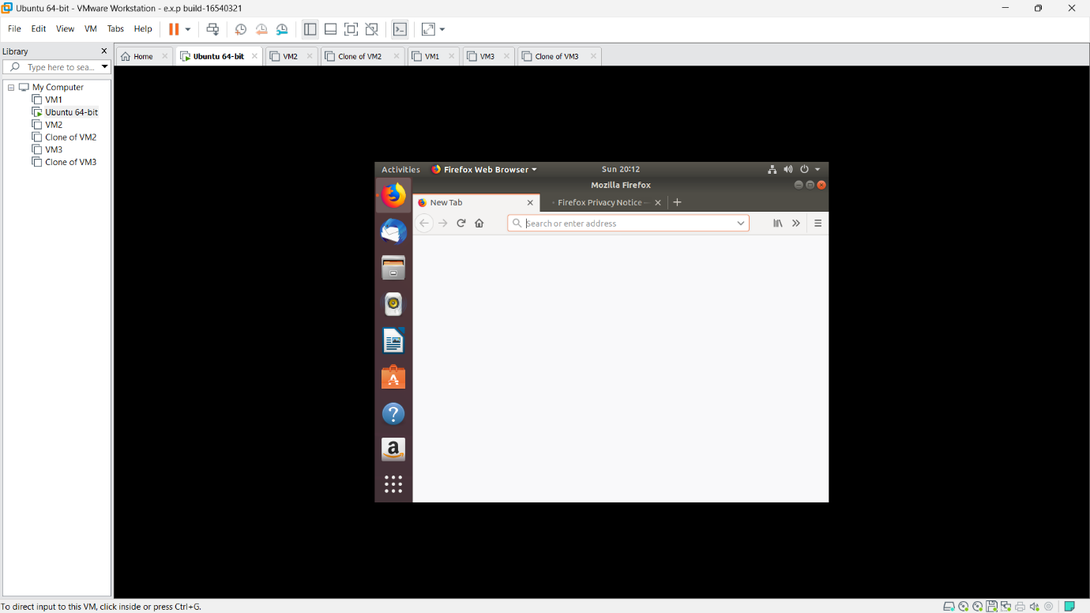

Step8: Enter the name of the virtual box and install the process of the virtual box.

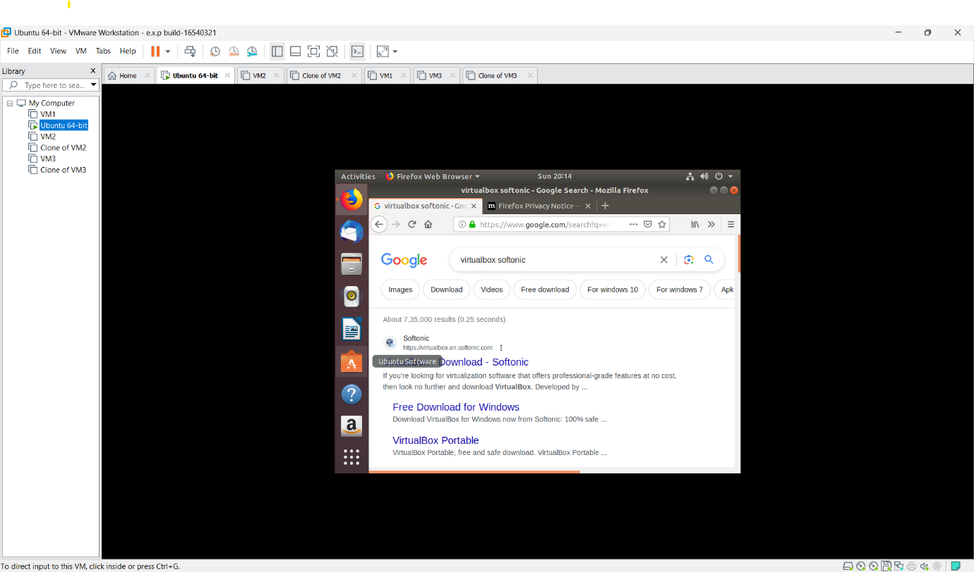

Step9: Download the virtual box for the latest version.

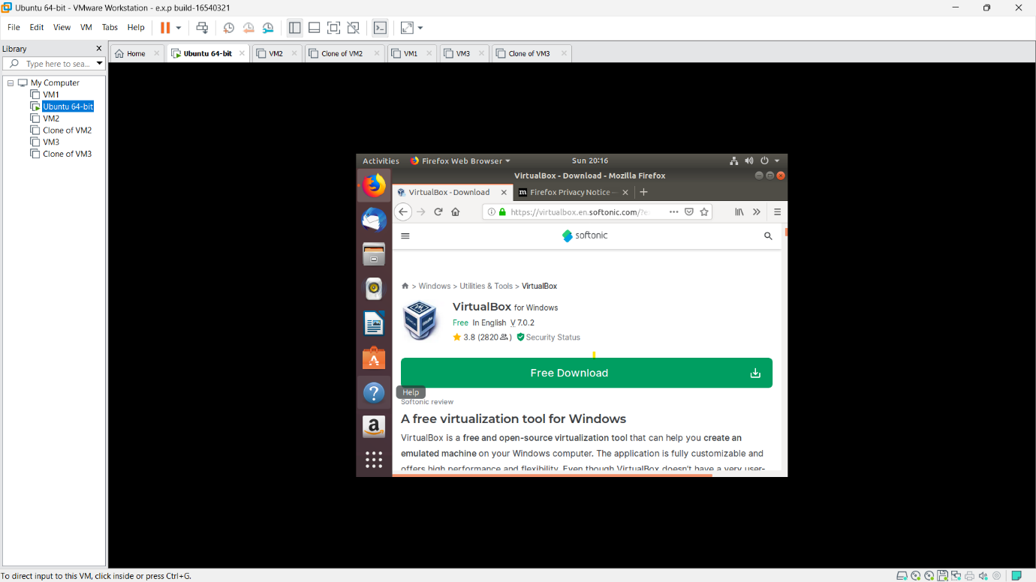



Step10: Complete the process of downloading virtual box and make the process to use it. 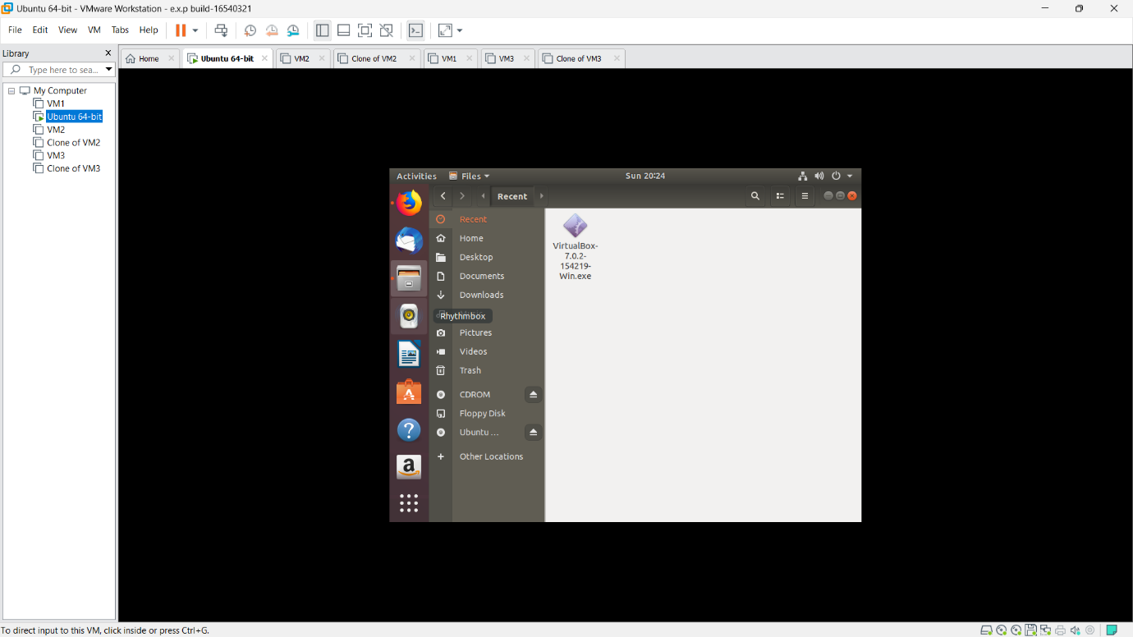

Hence the Virtual box downloaded successfully in the UBUNTU Operating systems.